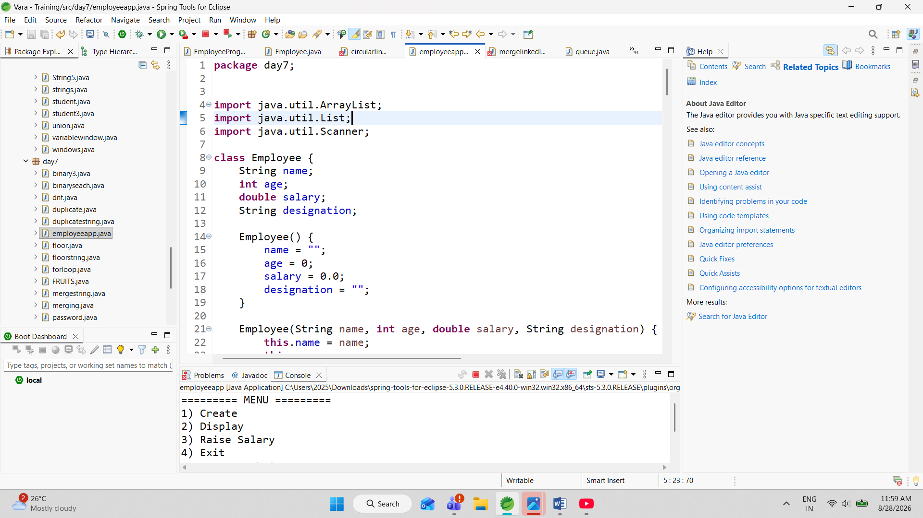

The Employee Management System is a menu-driven, console-based application developed using the Java programming language. The main purpose of this application is to provide a simple and efficient way to create, store, display, search, and update employee information.
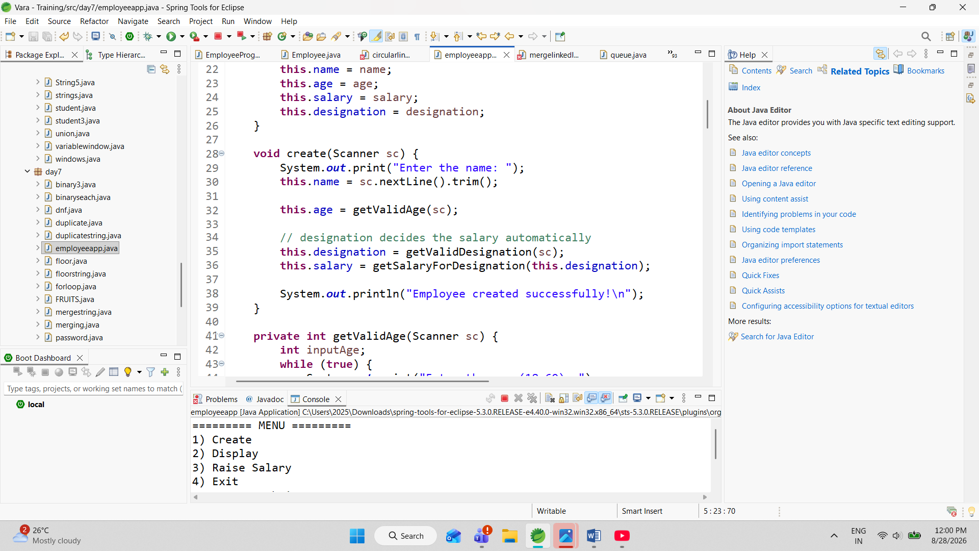
The application collects employee details such as name, age, designation, and salary. The user enters the required information during runtime using the Scanner class. The program validates the entered age to ensure that it is between 18 and 60 years. It also validates the employee's designation and accepts only Programmer, Manager, or Tester.

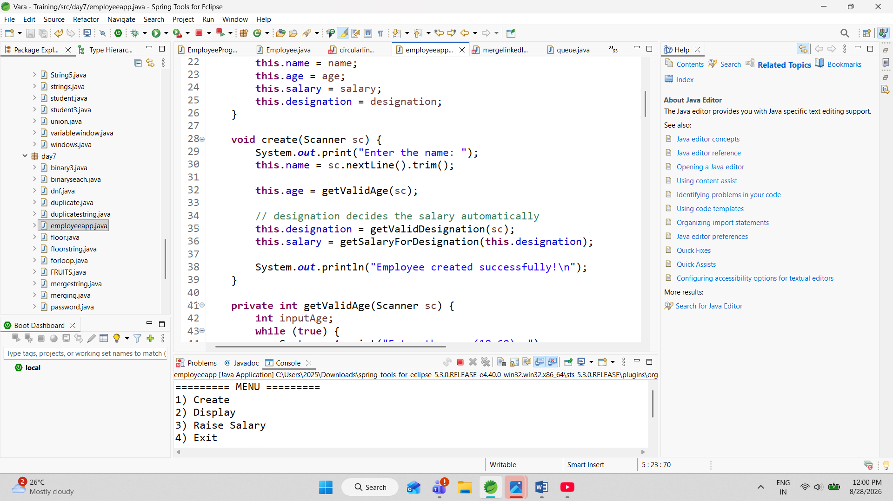
The salary is automatically assigned according to the selected designation. A Programmer receives a salary of ₹20,000, a Manager receives ₹25,000, and a Tester receives ₹15,000. This reduces manual salary entry and ensures that the salary is assigned consistently.



The application uses an ArrayList to store multiple employee objects. Whenever a new employee is created, the employee object is added to the list. The display option allows the user to view all the employees currently stored in the application.

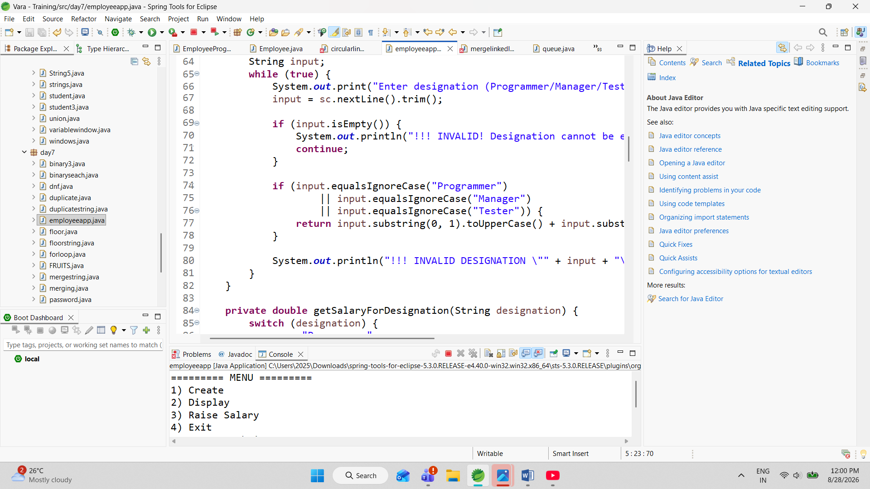

The program also provides a salary increment feature. The user can search for an employee by name and enter a raise percentage between 1% and 10%. The program calculates the raise amount and updates the employee's salary automatically.

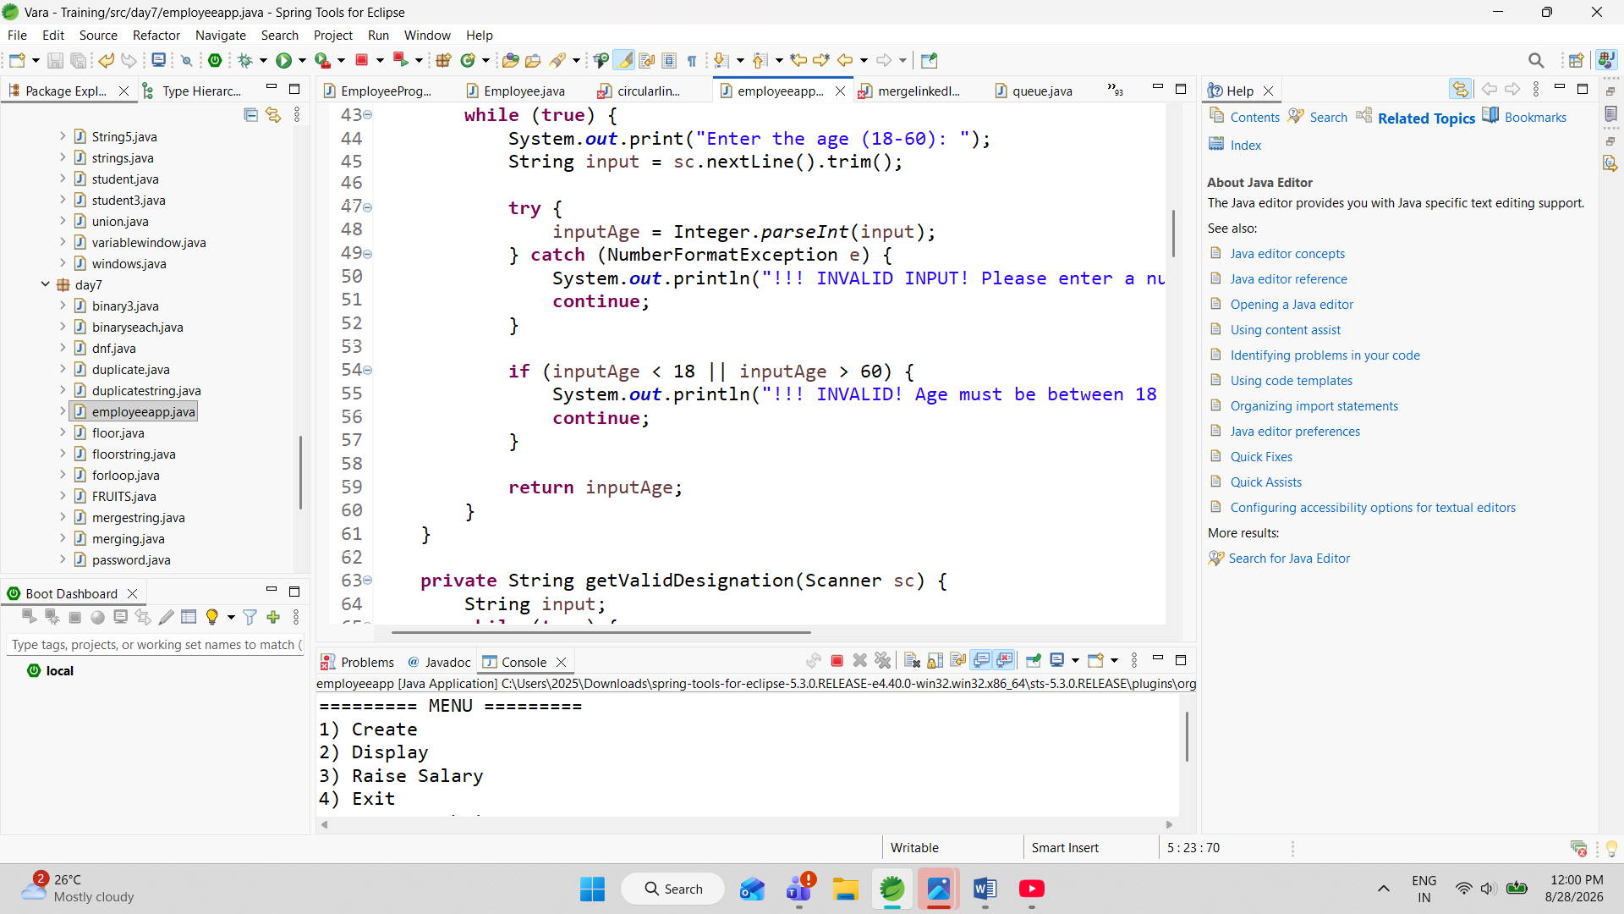

Input validation and exception handling are used throughout the application. For example, if the user enters text instead of a number for age or salary percentage, the program handles the NumberFormatException and asks the user to enter valid information again.

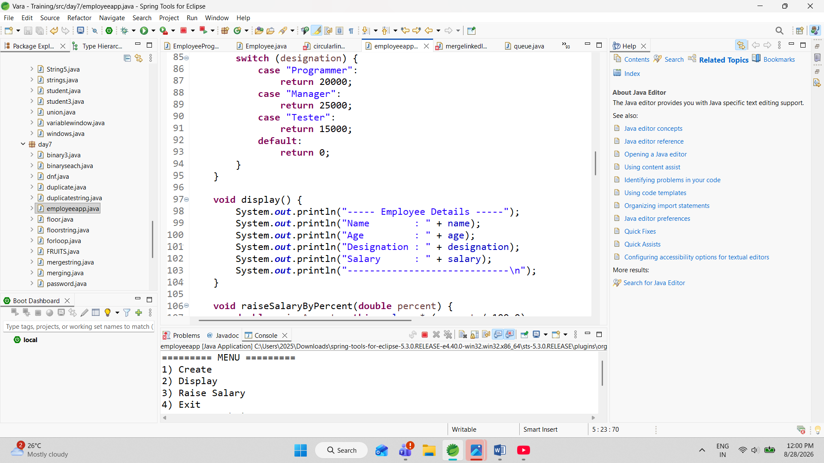

The project demonstrates several important Object-Oriented Programming (OOP) concepts. The Employee class represents an employee, constructors are used to initialize employee objects, methods are used to perform different operations, and the this keyword is used to refer to the current object's variables.

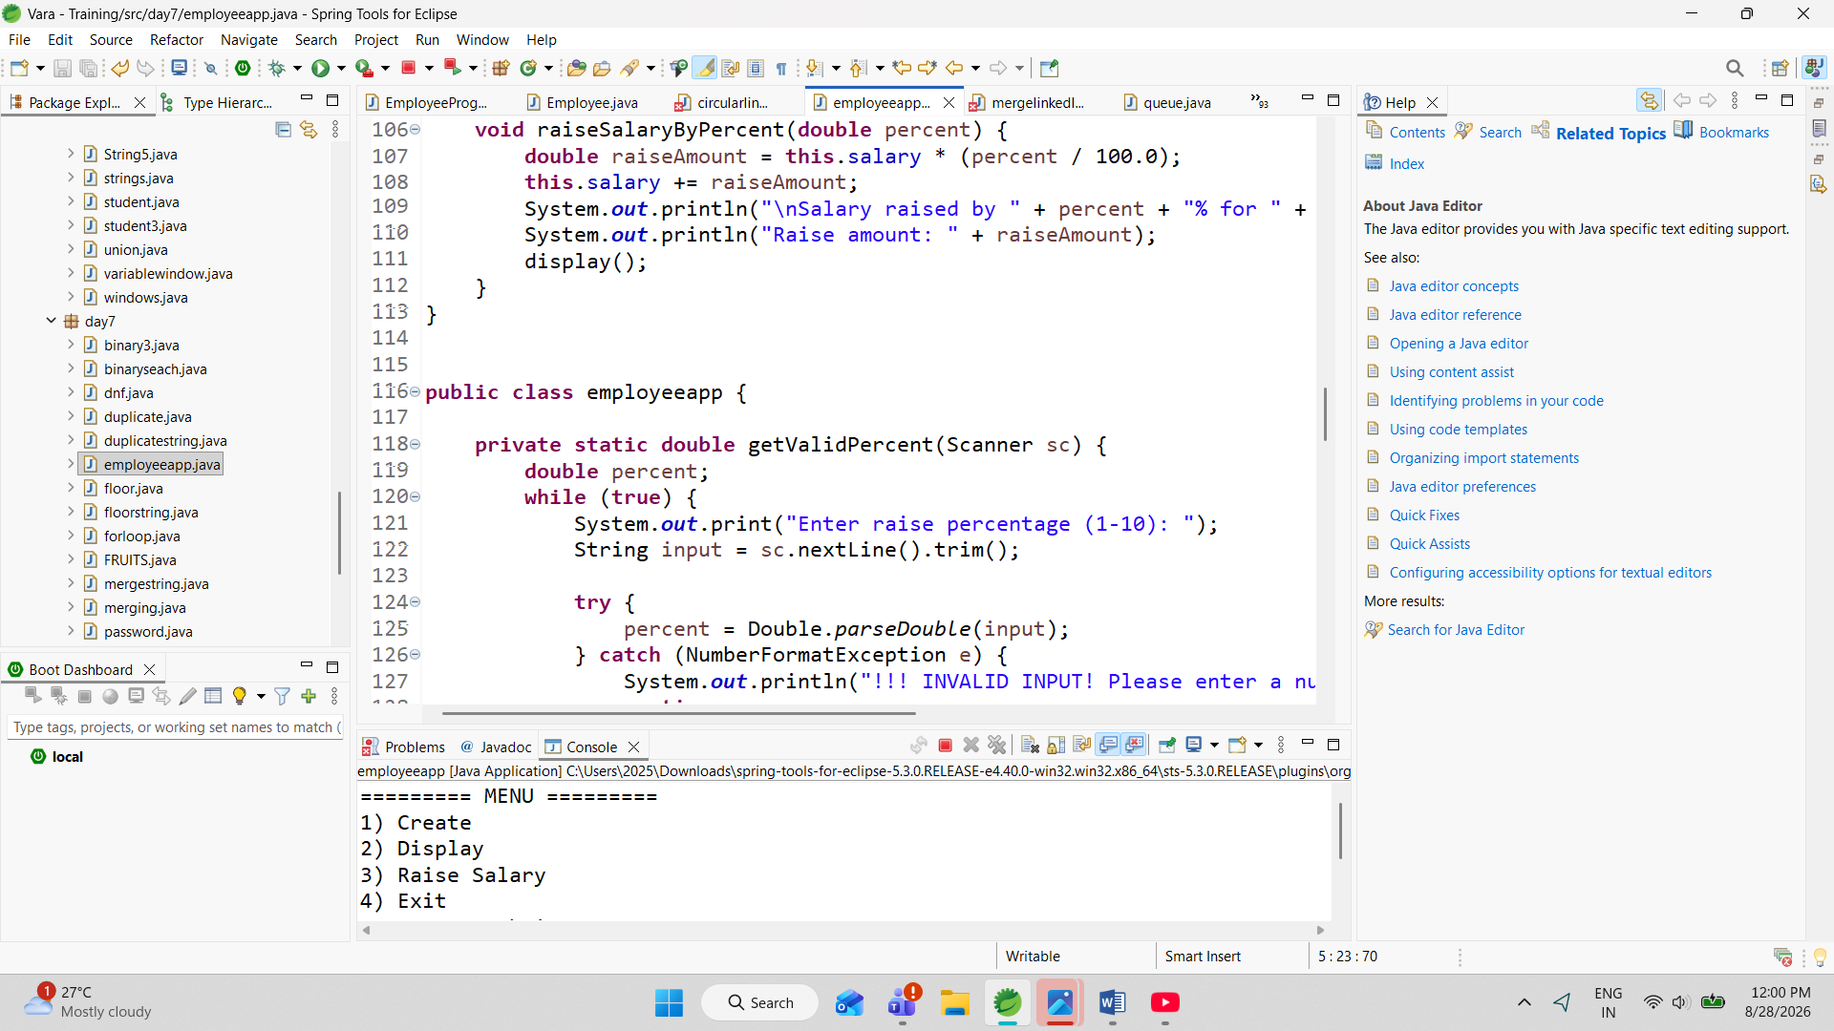

Overall, this project provides a practical example of how Java programming concepts can be combined to create a simple real-world application. It can later be enhanced by adding database connectivity, employee IDs, delete and update functions, file storage, sorting, searching, and a graphical user interface.

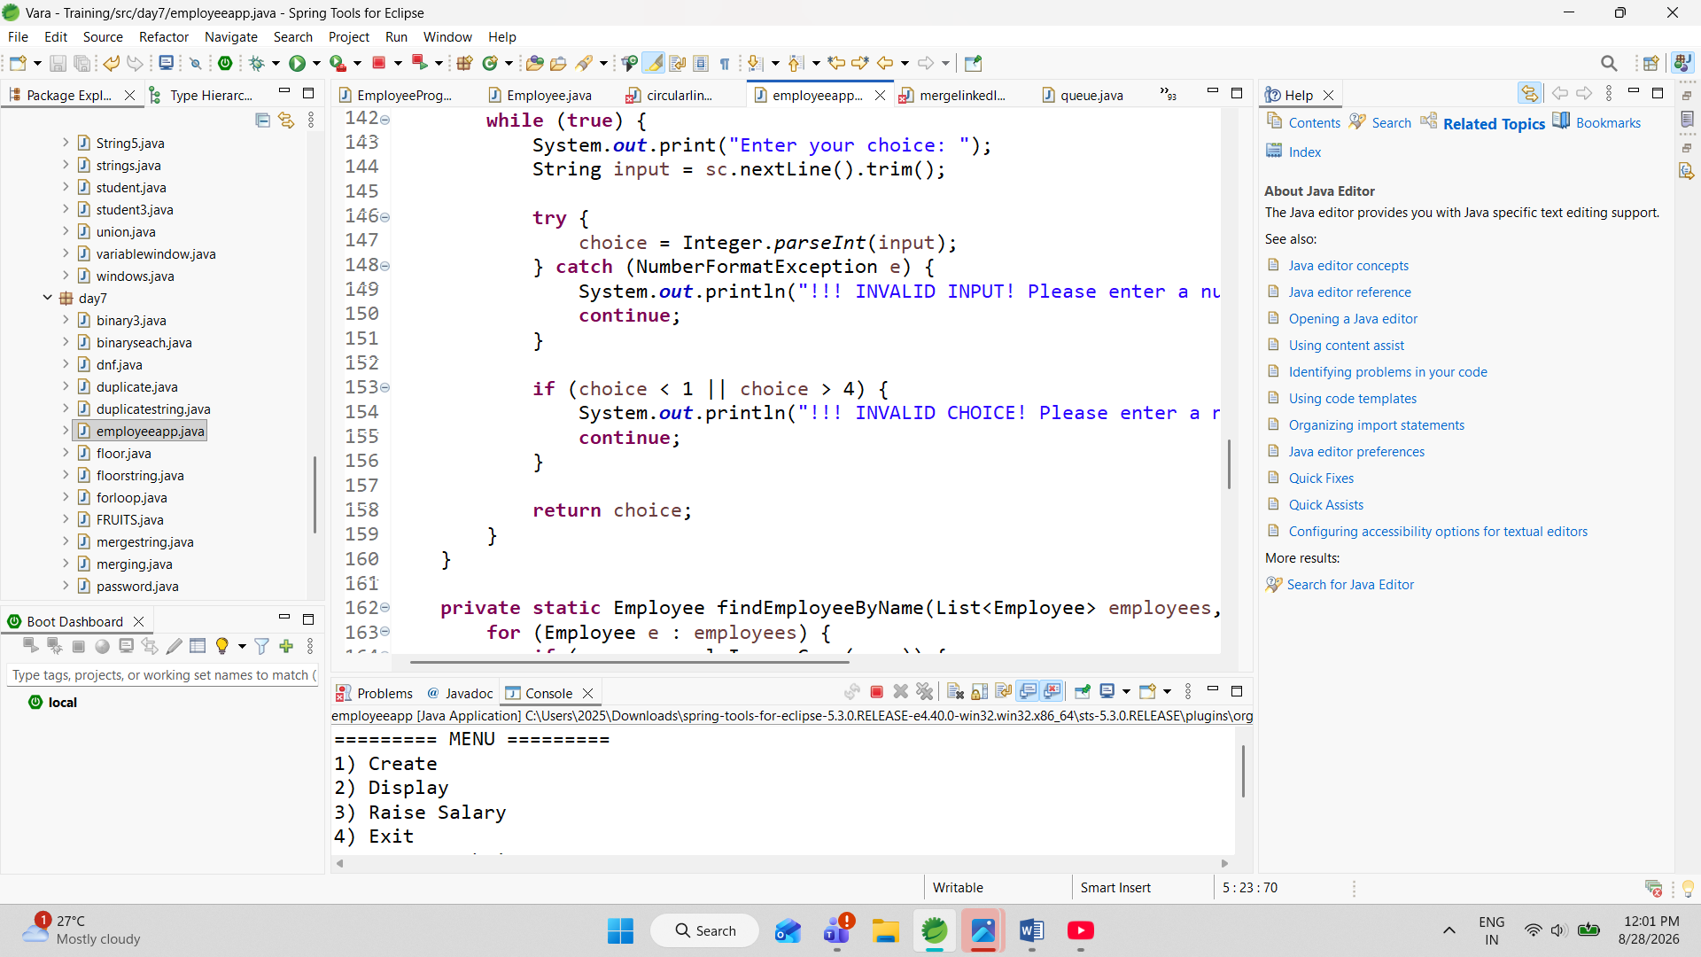

nput validation and exception handling are used throughout the application. For example, if the user enters text instead of a number for age or salary percentage, the program handles the NumberFormatException and asks the user to enter valid information again.



Employee Information
Each employee record contains the following information:
- Employee Name – The name of the employee.
- Age – The employee's age.
- Designation – The employee's job position.
- Salary – The employee's salary based on the designation.

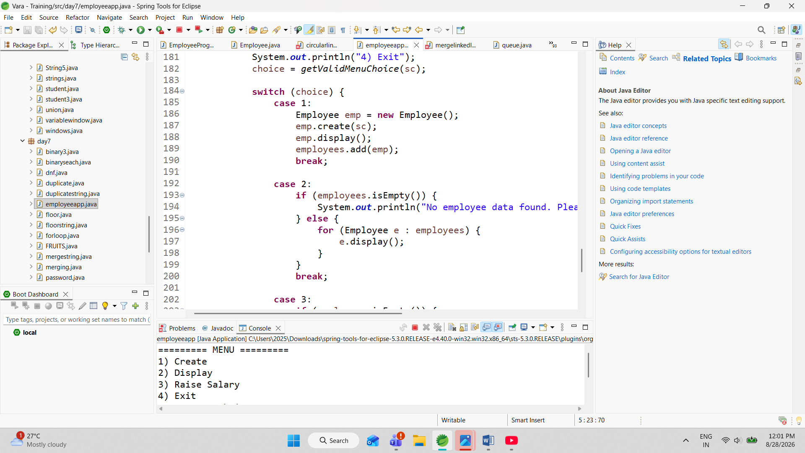

The project uses an ArrayList to store multiple employee objects. This allows the application to maintain several employee records during program execution. The system also performs input validation to ensure that the user enters valid information.
The application provides a simple menu containing four options: Create, Display, Raise Salary, and Exit. The Create option allows the user to add a new employee. The Display option shows all employee records. The Raise Salary option searches for an employee by name and increases the salary according to the percentage entered by the user. The Exit option terminates the application.

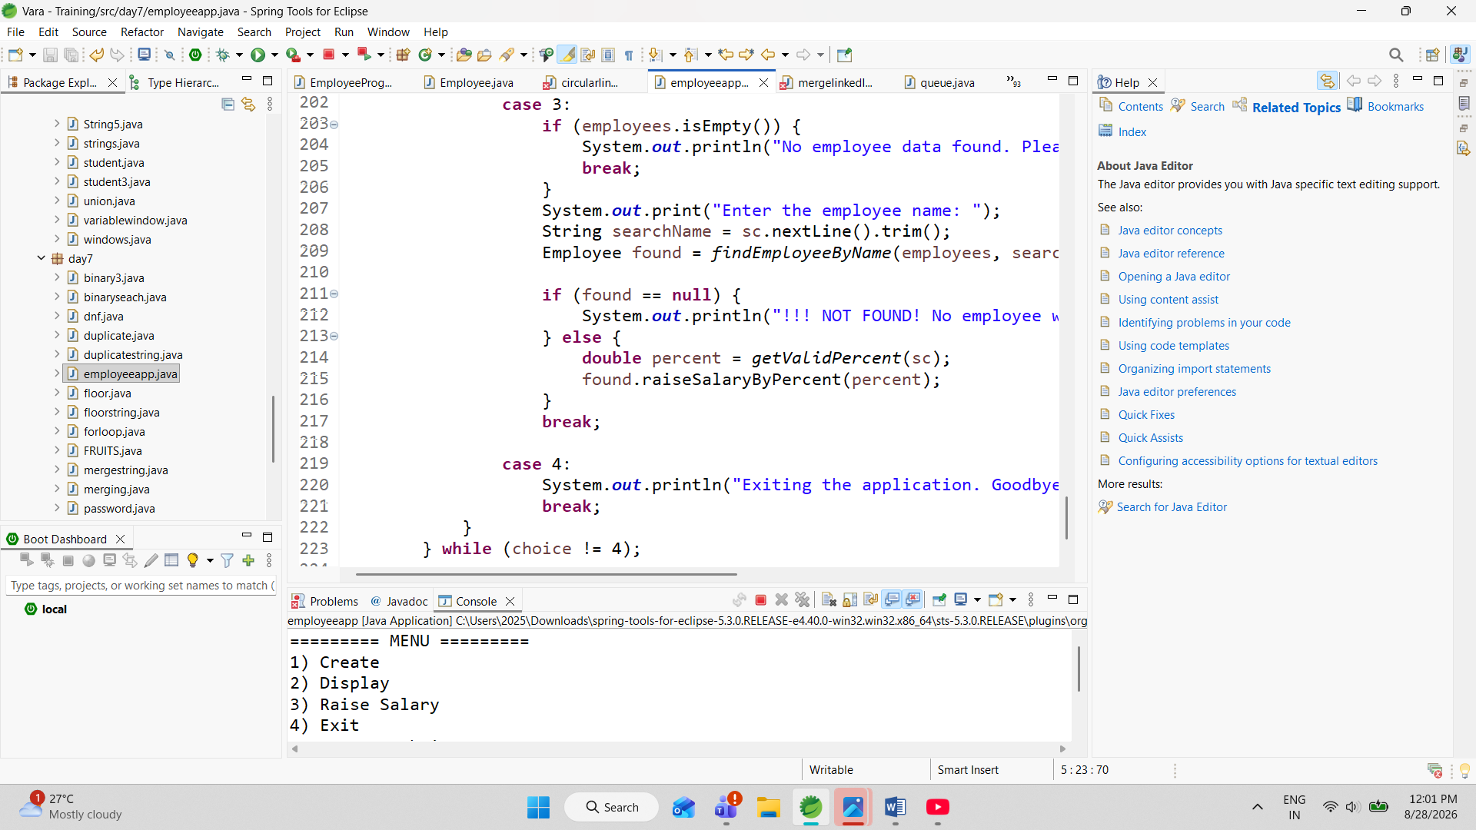

Managing employee information manually can be time-consuming and may lead to errors. There is a need for a simple system that can store employee details, display information, and perform basic salary management operations.
This project solves the problem by providing a computerized employee management system that can perform these operations quickly and accurately.

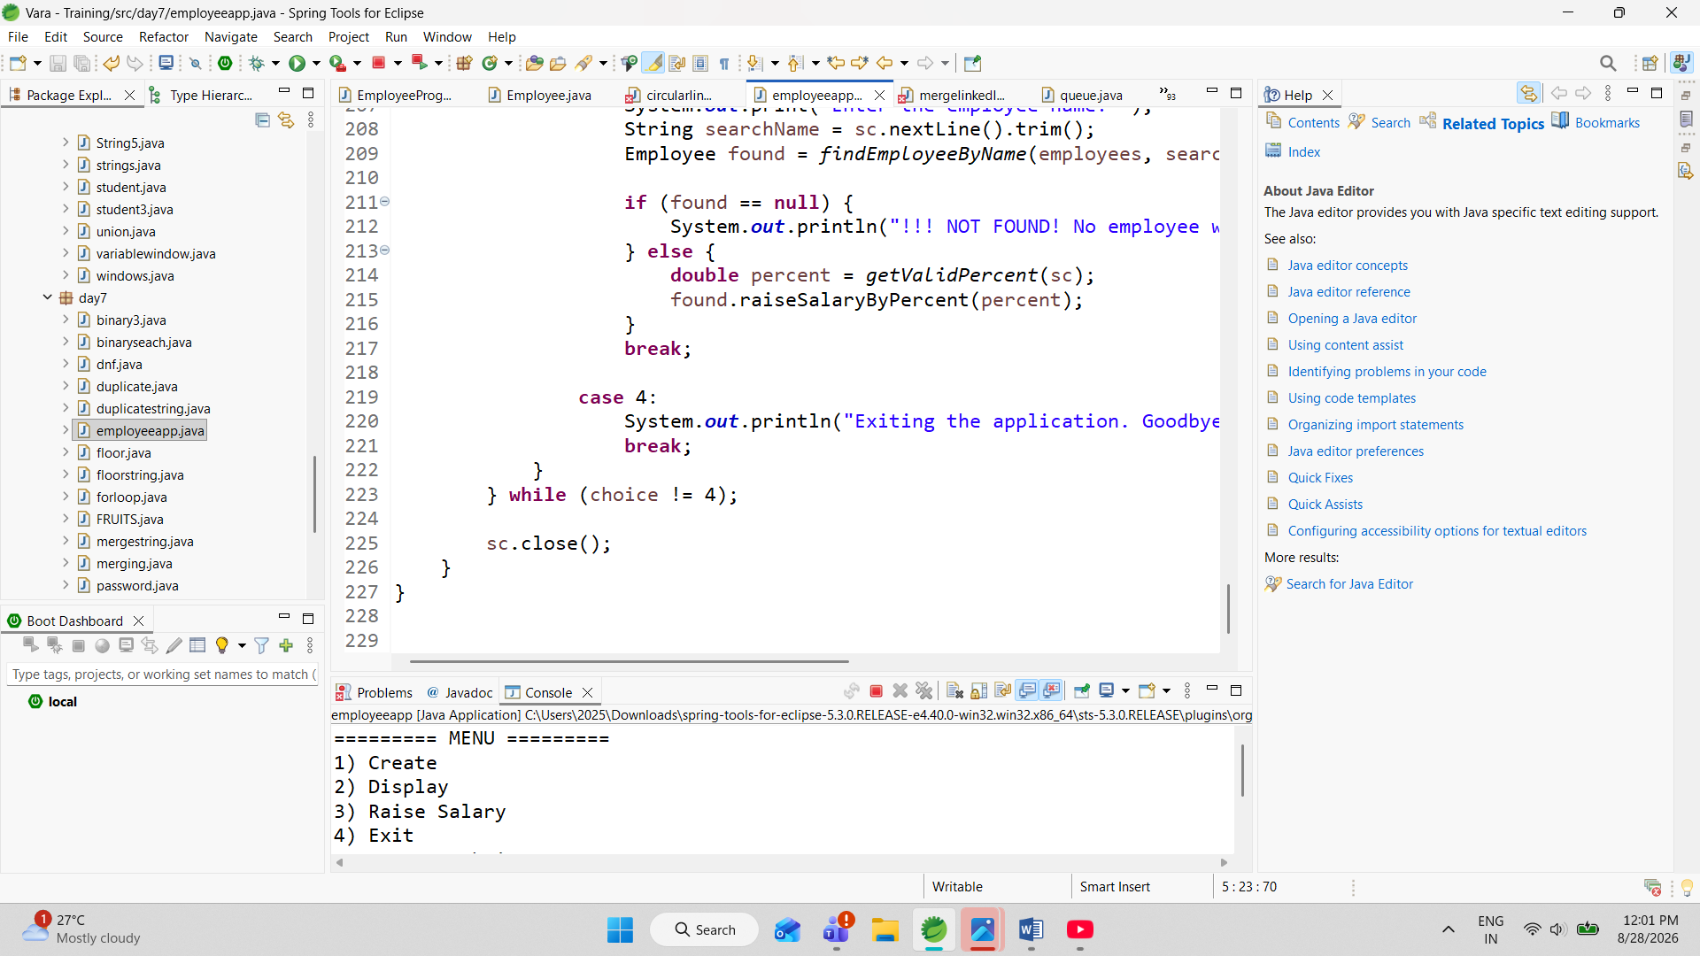

The Employee Management System provides a basic solution for maintaining employee records. It allows the user to enter employee information, store the information, view records, search for employees, and update salaries.
The application is designed as a menu-driven system, making it simple for users to select and perform different operations.



traditional employee management, information may be maintained using paper records or spreadsheets. These methods can result in duplicate information, calculation errors, and difficulty in searching records.
A programming-based employee management system can reduce these problems by organizing employee information into objects and providing methods to perform different operations.
Java is suitable for this project because it supports Object-Oriented Programming, collections, exception handling, and runtime input.

